Peas in a Pod
Kate Hickey

Peas grow inside little bags on the pea plant called “pods.” Some pods have more peas than others. Can you tell how many peas will be in a pod by measuring its length?
What do you think?
____________________________________________________________________________
____________________________________________________________________________
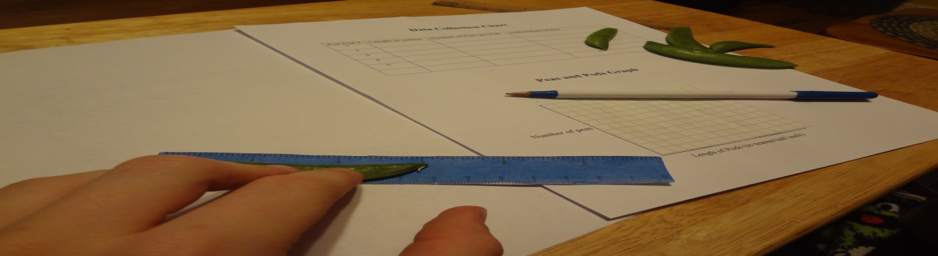

Prerequisites:
1. Student is able to measure lengths.
2. Student is able to apply the “look for a pattern” strategy in order to problem solve.
3. Student is able to plot points on a two-dimensional coordinate system.

Goal:
The student will be able to collect and record data and use the gathered information to form a valid conclusion.

Objectives:
1. Given a ruler, pea pods, and a blank chart, the student will collect and record data with 100% accuracy.
2. Given a complete data chart and graph paper, the student will plot and graph data to show the relationship between two variables with 100% accuracy.
Lesson Vocabulary:
Pattern - a predictable sequence of behavior
Variable(s) - a symbol representing an unspecified member of a set of objects

Materials:
- Ruler - Five pea pods
- Data collection chart - Pea and Pods graph

Procedure:
1. Start the lesson by dividing students into several small groups. Introduce the topic and have the students make a prediction.
2. Give each set of students a bag of pea pods, rulers, and data collection charts.
3. Have the students work together as they measure each pod in inches to the closest half inch.
4. Have the students record their measurements on the data collection charts along with any notes or observations they have.
5. Once all students have finished measuring all of their pods, have them open each of them. Have students count the number of peas in each pod and have them record the information on the data collection charts.
6. Using the Peas and Pods graph, have the students plot their data. (Remind students that they will need to alter the numbers on the X and Y axis based on how high their data points are.)
7. Have students study their graph. Do they see a pattern between the number of peas in a pod and the pods length? Have students work together to answer the attached questions.
8. Give students the opportunity to share any observations or patterns they have found with the class.
9. End the activity with a class discussion on what other types of items we could use this activity for. (For example, could you use it for spots on a caterpillar? What about the number of seeds inside an Italian roaster pepper?)

References:
Peas in a Pod math activity idea taken from
http://www.thefutureschannel.com/hands-on_math/peas_in_a_pod.php
Data Collection Chart

Pea Pod # | Length in inches: | Number of Peas per Pod: | Notes/Observations:
1

2

3

4

5

Think about it…….Do you see a pattern?

Peas and Pods Graph

Number of peas

Length of Pods (to nearest half inch)
Peas in a Pod

Name: _______________________________________ Date: ___________________

After completing the hands-on activity with your group members work together answering the following questions.

1. Could you predict how many peas were in each pod based on the pods length?
______________________________________________________________________________

2. What variables were involved in this activity? How many were there?
______________________________________________________________________________

3. Can you see a pattern between the variables? If so, what?
______________________________________________________________________________

4. Did using the graphs make it easier to see the patterns?
______________________________________________________________________________

5. Do you think that using data collection and graphs was a good way to see if there was a pattern and correlation between the number of peas and the pea pod length?
______________________________________________________________________________

